# 

# National University of Computer & Emerging Sciences – FAST Peshawar Campus

# *Assignment of DLD LAB*

* + - * + ***Subject: DLD Lab Assignment***
        + ***Instructor: Mam Anum Rashad***
        + ***Written By: Abdul Ghani Khan***
        + ***Roll No: 22P-9037***
        + ***Department: Computer Science***
        + ***Section: BS(CS)-2A2***

***Submit By Submit To***

***Abdul Ghani Khan Mam Anum Rashad***

***__________________ ___________________***

**Question#1**

**Illustrate the block diagram of 8x1 Multiplexer using 4x1 and 2x1 Multiplexers. Simulate this**

**design in Multisim to verify the working of these cascaded multiplexers.**

**Also, create the truth table for 8x1 Multiplexer.**

**Simulation File Of Multi Sim Attached in the folder For Both The Questions.**

***Truth Table: -*  
  
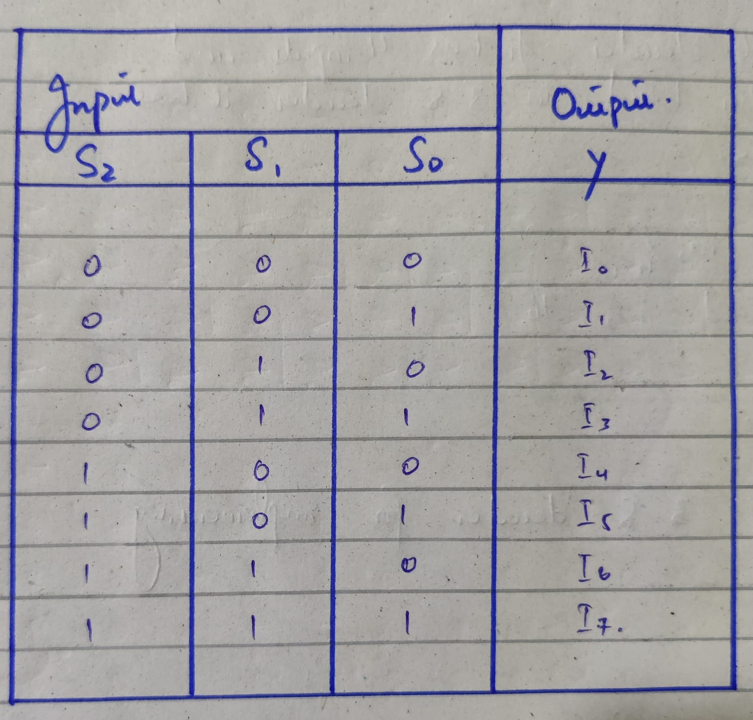**

***Circuit:-***

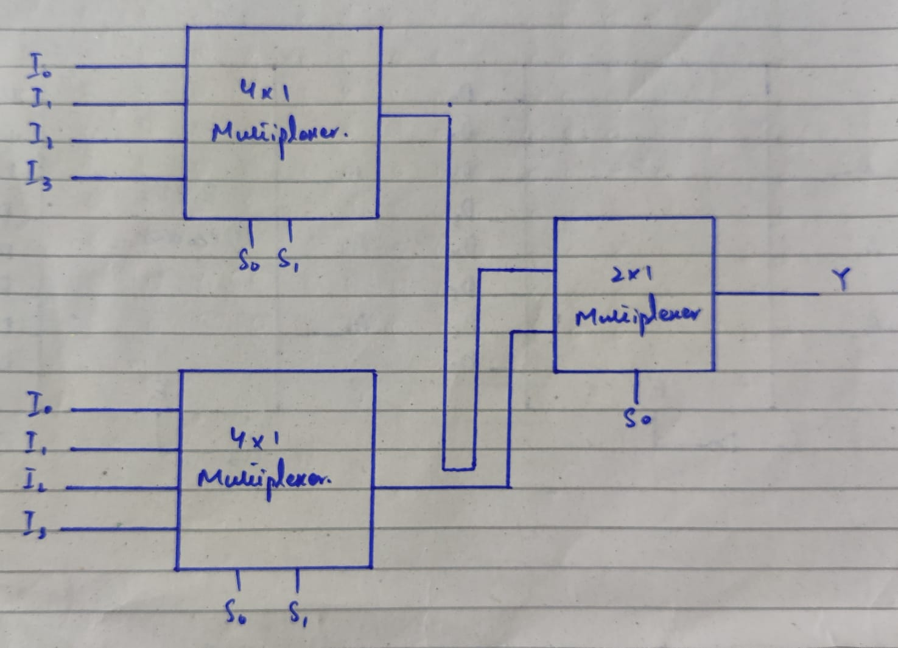

**Question#2**

**Illustrate the block diagram of 4 to 16 Decoder using 3 to 8 Decoders. You must show the**

**calculation for the number of lower order Decoders required for the design of 4 to 16 Decoder.**

**Simulate the design in MultiSim to verify the working of the circuit.**

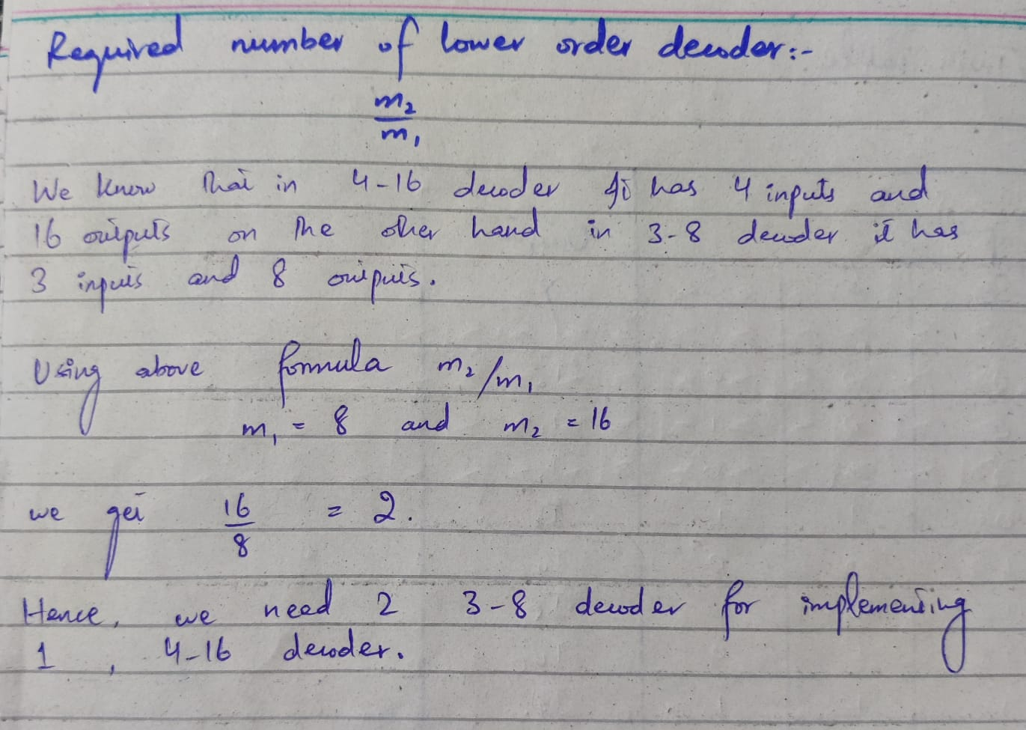

***Circuit:-***

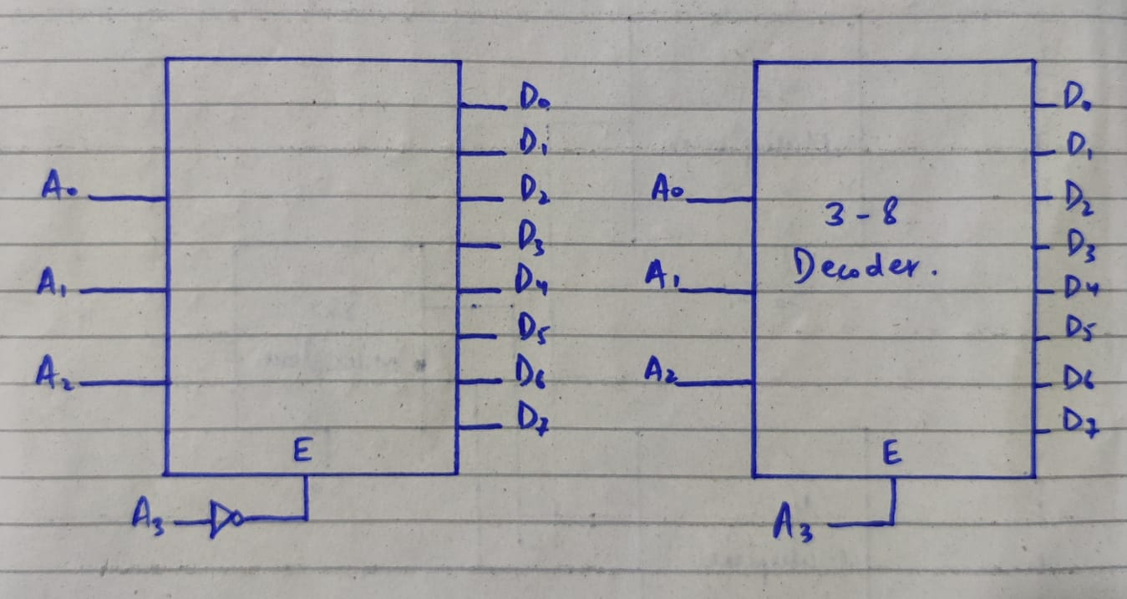

***Truth Table:-***

